Voice Acting Information for :
Nile Zam Jones
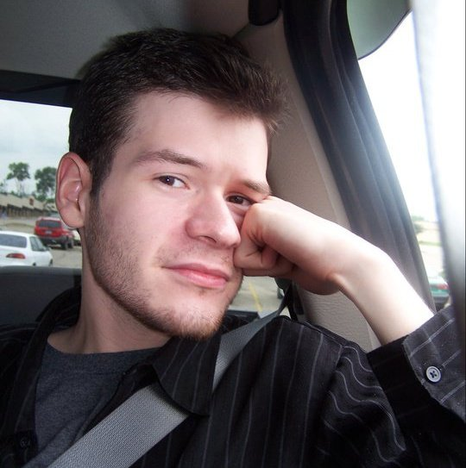
E-mail : Jawa_Man@hotmail.com
Location : U.S. – Northern Kentucky
Accents: American (Southern, Mid-western), Generic Slavic/Eastern European.
Youtube account (Contains various demo reels): Youtube.com/Nilezj
Bio: Nile is an aspiring voice actor and soon-to-be film student. Born and raised in the diverse and artistically-focused greater Cincinnati metropolitan area, he began doing small volunteer voice work for various projects at the age of 12. Now 19 (as of 2011), Jones has since grown an extraordinary love for the art of acting and filmmaking and plans to major in film study. He has recently broken into live-action film making with the short indie film “Yielded Nature”, and plans to film a full-length spiritual successor sometime next year.
Priding himself on his dedication and relentlessness in getting a role done to the best of his ability, Nile is always open to new voice work. Feel free to contact him!

